<<Tester name>>

<<App Name>>

Performance Test report

Test Summary:

|  |  |
| --- | --- |
| Test Window | 2020-06-01 05:06:00 AM to 2020-06-01 07:06:00 AM |
| Test Environment | UAT |
| Concurrent Users |  |
| Tool Used | Apache Jmeter |
| Base URL/IP Address | https://test.api.com/ |

Load Generators details:

|  |  |  |
| --- | --- | --- |
| Server Type | IP Address | Capacity/Tier Type |
| Load Generator |  |  |

Server Infrastructure details:

|  |  |  |
| --- | --- | --- |
| Server Type | IP Address/Hostname | Capacity/Tier Type |
| Application Server |  |  |
| Application Server |  |  |
| Application Server |  |  |
| Application Server |  |  |
| Application Server |  |  |
| DB Server |  |  |

Database Profile:

|  |  |
| --- | --- |
| Table | Metric(Row Count) |
| Identifiers | 127583394 |
|  |  |
|  |  |
|  |  |
|  |  |
|  |  |

Workload Model:

|  |  |  |  |
| --- | --- | --- | --- |
| # | Method Type | API Name/End Point | Achieved Request/Min |
| 1 | POST | */api/consent* | 480 |
| 2 |  |  |  |
| 3 |  |  |  |
| 4 |  |  |  |
| 5 |  |  |  |
| 6 |  |  |  |

Client Side Metrics - API Performance Summary:

|  |  |  |  |  |  |  |  |
| --- | --- | --- | --- | --- | --- | --- | --- |
| API Name/Label | Request Count | Response time (in milli seconds) | | | | Failure Percent | Throughput |
| Min. | Avg. | Max. | 90 Percentile |
|  |  |  |  |  |  |  |  |
|  |  |  |  |  |  |  |  |
|  |  |  |  |  |  |  |  |
|  |  |  |  |  |  |  |  |

Server Side Metrics – RDS Metrics:

|  |  |
| --- | --- |
| Metric name | Value |
|  |  |
|  |  |
|  |  |
|  |  |
|  |  |
|  |  |

Server Side Metrics – EC2 Metrics:

|  |  |
| --- | --- |
| Metric name | Value |
|  |  |
|  |  |
|  |  |
|  |  |
|  |  |
|  |  |

Observations & Analysis:

* *Few points about transaction performance such as how many deviated from SLA for avg. & 90 Percentile*
* *Few points about Resource utilization such as 40% of CPU used as an Avg., 50% memory used for application tiers*
* Few points about DB Performance, i.e., top slow queries and avg. query time for Consent API. Etc…

Server Side Metrics – RDS Charts:

CPU:

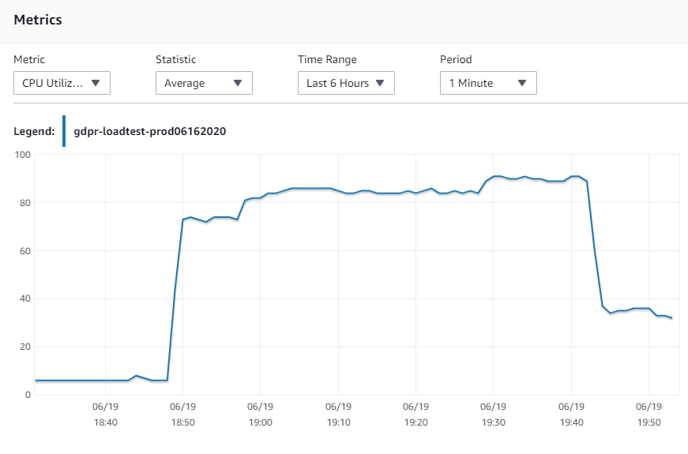

Server Side Metrics – EC2 Charts:



Test Logs:

**<Jmeter Test Results path>**